Ordinal Numerals

✅ Definition:
# Source: AI Source: Provided by: [Data Path: Persons Table -> ID Column: 1, Name_En Column: Motasem Essam] -> From: [Chatgpt (GPT-4-turbo)] on [7/28/2025]
Ordinal numerals are words that express position, rank, or order in a sequence.
They answer the question: “Which one?” or “In what order?”

🧩 Examples of Ordinal Numerals:
# Source: AI Source: Provided by: [Data Path: Persons Table -> ID Column: 1, Name_En Column: Motasem Essam] -> From: [Chatgpt (GPT-4-turbo)] on [7/28/2025]
- first, second, third
- fourth, fifth, tenth
- twenty-first, hundredth, thousandth

✏️ Examples in Sentences:
# Source: AI Source: Provided by: [Data Path: Persons Table -> ID Column: 1, Name_En Column: Motasem Essam] -> From: [Chatgpt (GPT-4-turbo)] on [7/28/2025]
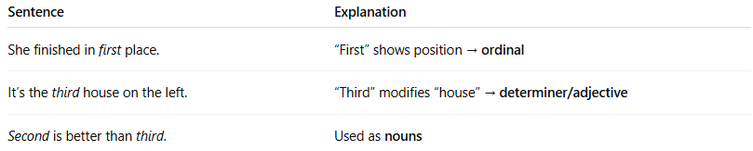
Sentence | Explanation
She finished in first place. | “First” shows position → ordinal
It’s the third house on the left. | “Third” modifies “house” → determiner/adjective
Second is better than third. | Used as nouns

📌 Grammatical Function:
# Source: AI Source: Provided by: [Data Path: Persons Table -> ID Column: 1, Name_En Column: Motasem Essam] -> From: [Chatgpt (GPT-4-turbo)] on [7/28/2025]
Ordinal numerals can function as:
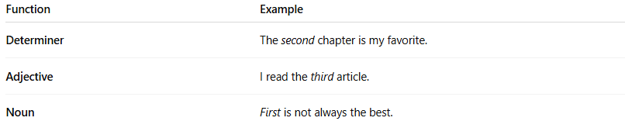
Function | Example
Determiner | The second chapter is my favorite.
Adjective | I read the third article.
Noun | First is not always the best.

🔍 Properties of Ordinal Numerals:
# Source: AI Source: Provided by: [Data Path: Persons Table -> ID Column: 1, Name_En Column: Motasem Essam] -> From: [Chatgpt (GPT-4-turbo)] on [7/28/2025]
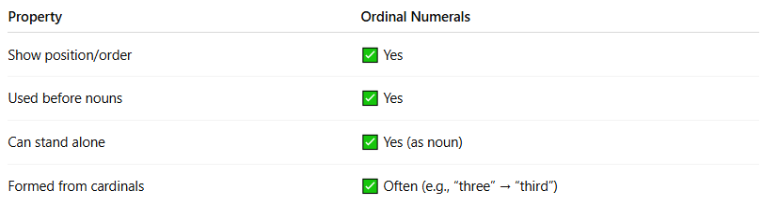
Property | Ordinal Numerals
Show position/order | ✅ Yes
Used before nouns | ✅ Yes
Can stand alone | ✅ Yes (as noun)
Formed from cardinals | ✅ Often (e.g., “three” → “third”)

⚠️ Note:
# Source: AI Source: Provided by: [Data Path: Persons Table -> ID Column: 1, Name_En Column: Motasem Essam] -> From: [Chatgpt (GPT-4-turbo)] on [7/28/2025]
- Ordinal ≠ Cardinal: “Three” = how many; “Third” = which one
- Ordinals are commonly used in dates and races:
  - July 4th, 1st prize

🧠 Summary:
# Source: AI Source: Provided by: [Data Path: Persons Table -> ID Column: 1, Name_En Column: Motasem Essam] -> From: [Chatgpt (GPT-4-turbo)] on [7/28/2025]
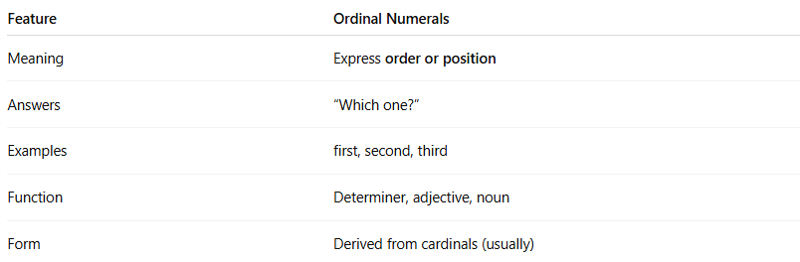
Feature | Ordinal Numerals
Meaning | Express order or position
Answers | “Which one?”
Examples | first, second, third
Function | Determiner, adjective, noun
Form | Derived from cardinals (usually)

